Chapter 10. Basic Debugging
The debugger is your friend. There is simply no more powerful tool than a debugger for learning C# and for writing quality C# programs. The debugger helps you understand what is really going on when your program is running. It is the x-ray of software development, allowing you to see inside programs and diagnose potential problems.
Without a debugger you are guessing; with a debugger you are seeing. It is as simple as that. Whatever time you invest in learning to use your debugger is time well spent.
The debugger is also a powerful tool for understanding code written by others. By putting someone else's code into the debugger and stepping through it, you can see exactly how the methods work and what data they manipulate.
This book assumes you are working with Visual Studio .NET. The debugger we'll investigate is the powerful symbolic debugger integrated within Visual Studio .NET.
The VS.NET debugger provides a number of windows for watching and interacting with your program while it executes. Getting comfortable with the debugger can make the difference between quickly finding bugs and struggling for hours or days.

10.1 Setting a Breakpoint
To get started with the debugger, return to Example 9-1. Put a breakpoint on the first line of Main() to see how this code actually works. A breakpoint is an instruction to the debugger to stop running. You set a breakpoint and then run the program and the debugger runs the program up until the breakpoint. Then you have the opportunity to examine the value of your variables at this point in the execution. Examining your program as it runs can help you untangle otherwise impenetrable problems. It is common to set multiple breakpoints, which allows you to zip through your program, examining the state of your object at selected locations.
You can set a breakpoint in many different ways. The easiest is to click in the far-left margin. This causes a red dot to appear in the margin next to the relevant line of code, which is also highlighted in red, as shown in Figure 10-1. Notice that as you hover over the breakpoint it tells you the line on which the breakpoint appears.
Figure 10-1. Setting a breakpoint
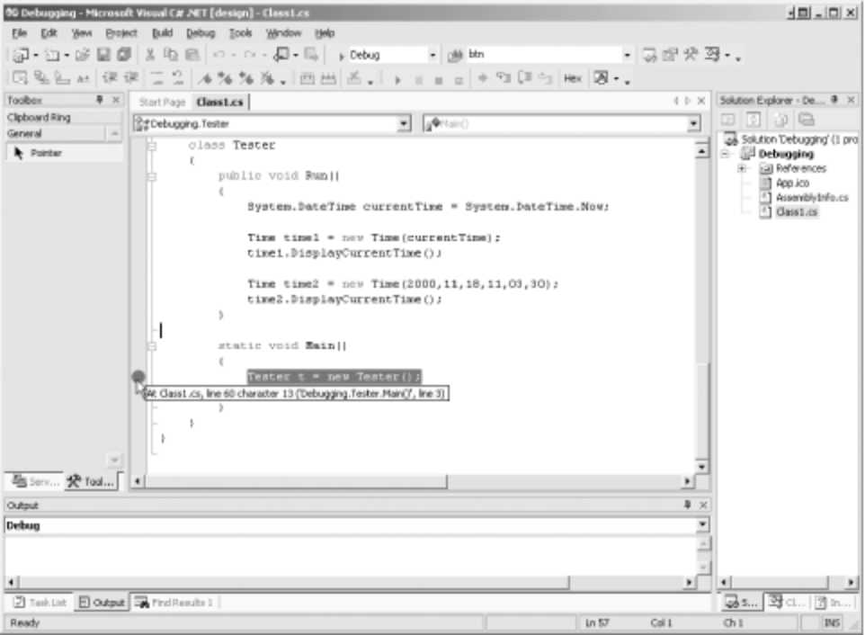
You are now ready to run the program to the breakpoint. Again, there are a number of ways to do so. You can click on the Start button (see Figure 4-6), or you can choose the Start item from the Debug menu (or use the keyboard shortcut for the menu item, the F5 key). In any case, the program starts and runs to the breakpoint, as shown in Figure 10-2.
Figure 10-2. At the breakpoint
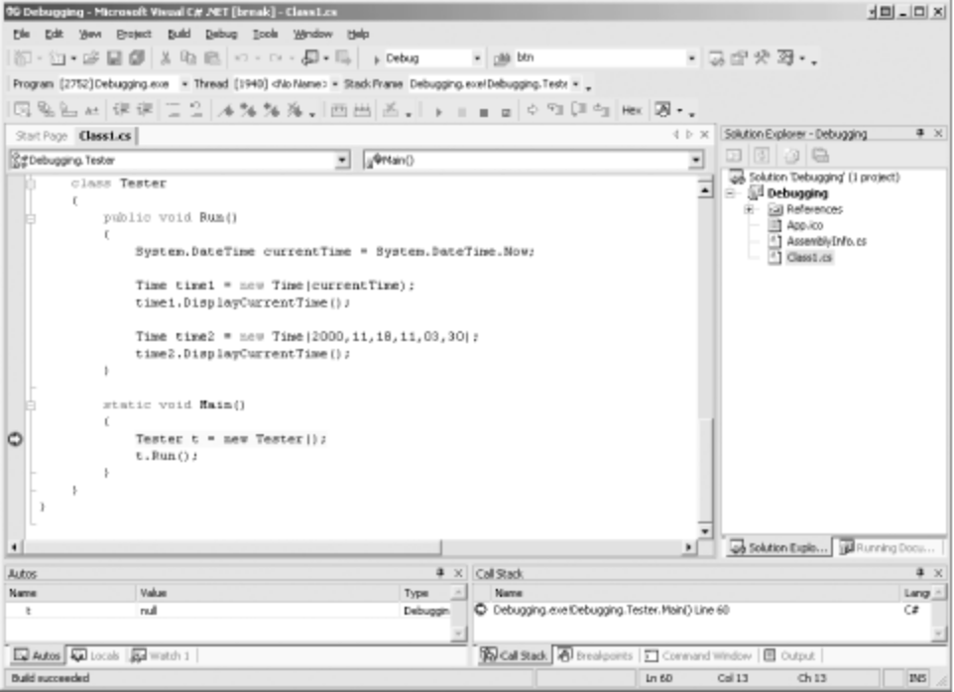
The next statement to be executed is highlighted (in this case, the instantiation of the Tester object). There are a number of other helpful windows open as well, which will be examined in detail.
To step into the code, press the F11 function key twice. With the first keypress, the Tester is created. The second keypress moves you to the next line in the code, which calls the Run() method. Press the key once more to step inside the code for the Run() method and assign the value of System.DateTime.Now to the currentTime variable.
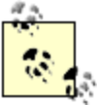 | F11 and F10 are the step commands. The difference between them is that F10 steps over method calls, while F11 steps into them.  The methods are executed with F10, but you don't see each step in the debugger; the highlighting jumps to the next statement past the method call.  If you use F11 to step into a method you meant to step over, Shift-F11 will step you out. The method you stepped into will run to completion, and you'll break on the first line back in the calling method.  In the code shown in Figure 10-2, there is no functional difference between using F10 and using F11 because all the work is done in a single method.

10.1.1 Using the Debug Menu to Set Your Breakpoint
Rather than clicking in the margin to set your breakpoint, you can use the New Breakpoint item on the Debug menu (or use the keyboard shortcut for the menu item, Control-B). This brings up the New Breakpoint dialog box, as shown in Figure 10-3.
Figure 10-3. The New Breakpoint dialog
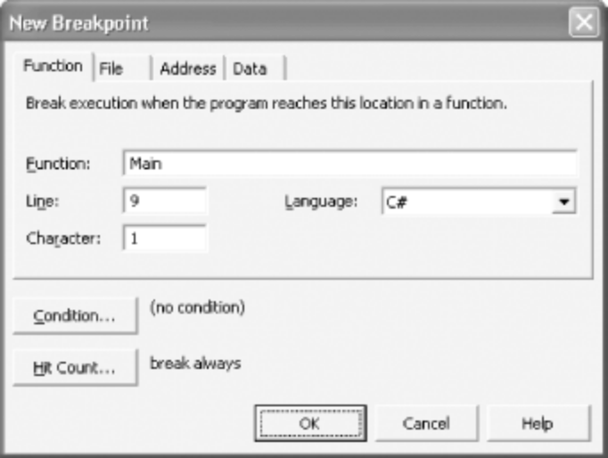
The New Breakpoint dialog gives you far greater control over your breakpoint. For example, you can set it to break only when a specific condition is hit (e.g., when counter > 10).
You can also set the hit count to designate that you only want the debugger to break in when the line has been hit a specified number of times (or a multiple of a specific number, etc.), as shown in Figure 10-4.
Figure 10-4. Breakpoint hit count
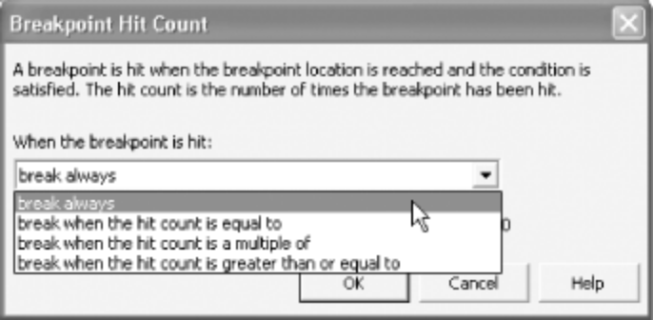
This can be very useful when you are in a loop (as described in Chapter 6). Rather than breaking each time through a loop of 100 iterations, you can choose the conditions under which to break.
You can also examine and manipulate all the breakpoints together in the breakpoint window, as shown in Figure 10-5.
Figure 10-5. The Breakpoints window
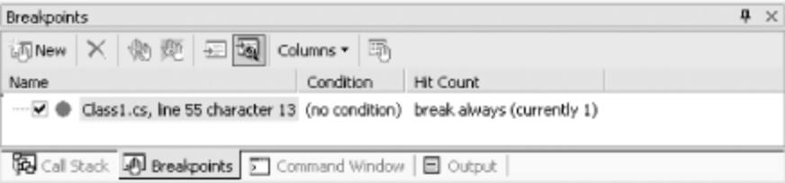
10.1.2 Examining Values: The Autos and Locals Windows
Look at the bottom left-hand windows, where your variables are displayed. These variables are organized in windows named Autos and Locals, as shown in Figure 10-6.
The debugger stacks the Autos and Locals windows together with tabs as shown in Figure 10-6. You are free to separate these windows or to move them to be tabbed with other windows. You can simply drag and drop the windows where you want them. When you drop one window on another, the two windows are tabbed together.

You can use the Autos and Locals windows to display the current value of each variable (and parameter) in your program. The Autos window shows variables used in the current statement and the previous statement. (The current statement is the statement at the current execution location, which is highlighted automatically in the debugger -- thus the window's name.) The Locals window displays all the variables in the current method, including parameters. In Figure 10-6, the Autos window shows you that the current time has been set to the current date.
Figure 10-6. The Autos window
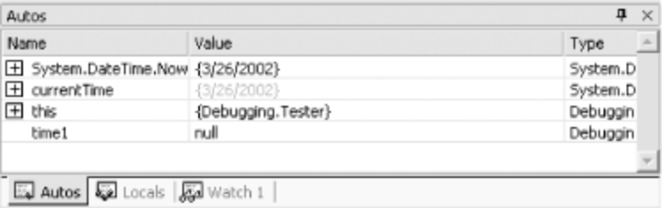
Since the value of currentTime has just been set it is shown in red. Notice the plus sign (+) next to the currentTime variable. This variable is of type System.DateTime, which is a type with many members. Expanding the plus sign reveals the state of this object, as shown in Figure 10-7.
Figure 10-7. Expanding the variable
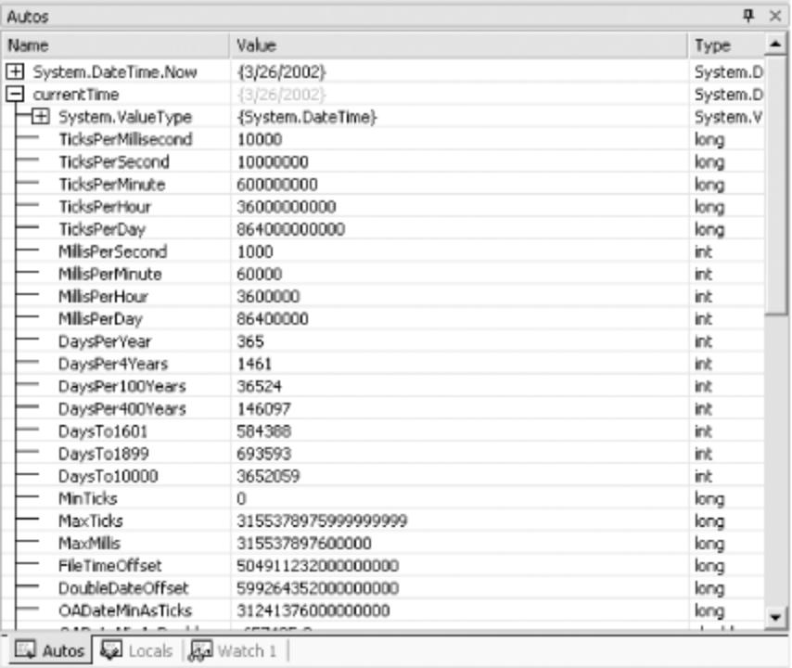
Press F11 again to step into the Time class constructor. When you step into the Time constructor, the Autos window changes to show you the new values, appropriate to the current line of code.
The debugger also provides a way for you to look at all the variables in the current method simultaneously: the Locals window. In this series of examples, clicking on the Locals window reveals the local variables dt (the parameter) and this (the current object). Expand the this variable and you'll see the Time object, with its controls uninitialized. Press F11 to progress through the assignment of values to the member variables of the Time class. As you hit the F11 key, the update is reflected in the Locals window, as shown in Figure 10-8.
Figure 10-8. Watching assignment
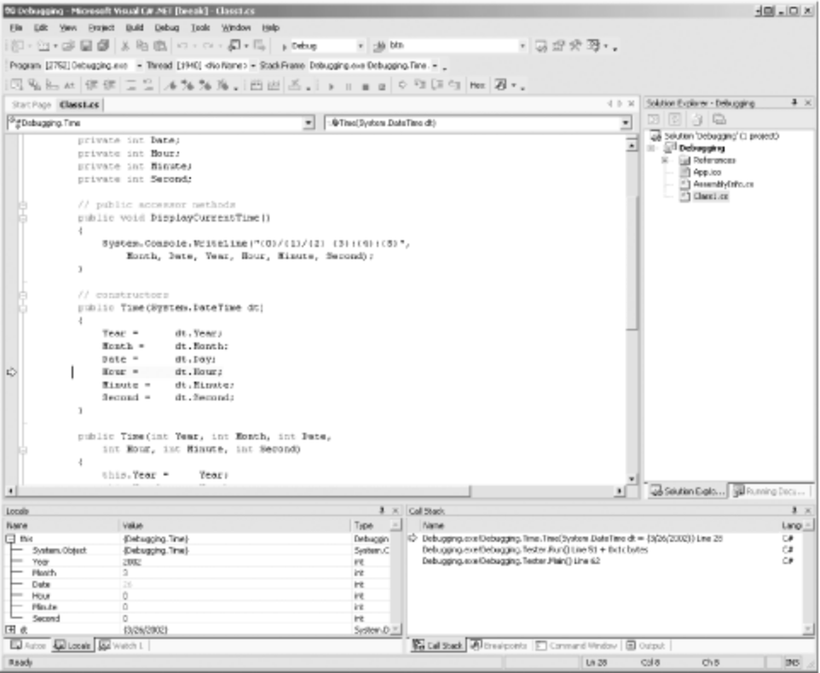
Explore the Locals and Autos windows as you step through the program. When you want to stop, choose the Stop debugging item from the Debug menu to stop processing and return to the editor.
10.1.3 Set Your Watch
In a program with many local variables, it can be difficult to keep track of the particular variables you want to keep an eye on. You can track variables and objects in the Watch window. You can have up to four Watch windows at a time. Watch windows are like by-invitation versions of the Locals window; they list the objects you ask the debugger to keep an eye on, and you can see their values change as you step through the program, as illustrated in Figure 10-9.
Figure 10-9. A Watch window
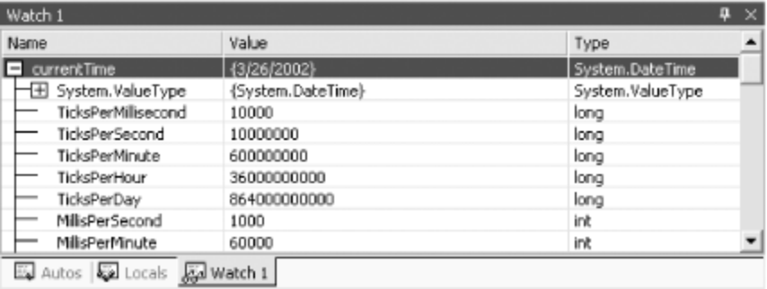
The Watch windows are usually tabbed with the Locals window. You can create more than one Watch window to organize the variables you keep an eye on.
You can add a watch by right-clicking on a variable and choosing Add Watch. You might instead choose Add QuickWatch, which opens a dialog box with watch information about a single object, as shown in Figure 10-10.
Figure 10-10. QuickWatch
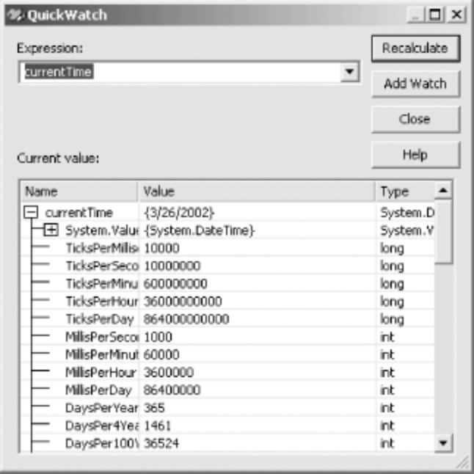
You can enter any expression and evaluate it from within the QuickWatch window. For example, suppose you had integer variables named varOne and varTwo:
int varOne = 5;
int varTwo = 7;
If you want to know the impact of multiplying them, enter:
varOne * varTwo
into the Expression window and click Recalculate. The value is shown in the Current value window, as in Figure 10-11.
Figure 10-11. QuickWatch recalculation
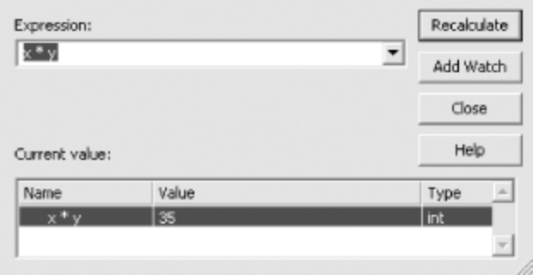

10.2 The Call Stack
As you step in and out of methods, the Call Stack window keeps track of the order and hierarchy of method calls. If you look back at Figure 10-2, you'll see the Call Stack window in the lower right-hand corner of the application. Figure 10-12 shows a close-up picture of the Call Stack window. You can see that the Time constructor was called by the Run() method, while the Run() method was in turn called by Main().
Figure 10-12. The Call Stack window
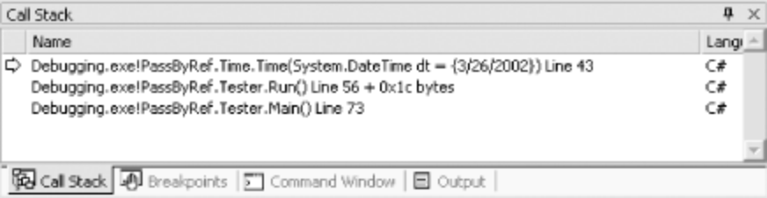
In this case, if you double-click on the second line in the Call Stack window, the debugger shows you the line in Run() that called the Time constructor, as shown in Figure 10-13.
Figure 10-13. Tracing the call stack
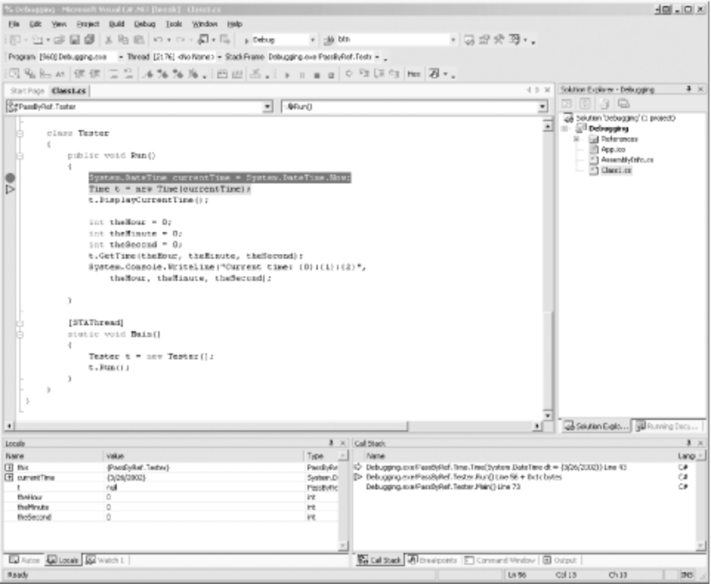

Chapter 11. Inheritance and Polymorphism
In Chapter 8 you learned how to create new types by declaring classes, and in Chapter 3 you saw a discussion of the principle object relationships of association, aggregation, and specialization. This chapter focuses on specialization, which is implemented in C# through inheritance. This chapter also explains how instances of more specialized classes can be treated as if they were instances of more general classes, a process known as polymorphism. This chapter ends with a consideration of sealed classes, which cannot be specialized, and a discussion of the root of all classes, the Object class.

11.1 Specialization and Generalization
Classes and their instances (objects) do not exist in a vacuum but rather in a network of interdependencies and relationships, just as we, as social animals, live in a world of relationships and categories.
One of the most important relationships among objects in the real world is specialization, which can be described as an is-a relationship. When we say that a Dog is a mammal, we mean that the Dog is a specialized kind of Mammal. It has all the characteristics of any Mammal (it bears live young, nurses with milk, has hair), but it specializes these characteristics to the familiar characteristics of canine domesticus. A Cat is also a mammal. As such we expect it to share certain characteristics with the Dog that are generalized in Mammal, but to differ in those characteristics that are specialized in Cat.
The specialization and generalization relationships are both reciprocal and hierarchical. They are reciprocal because specialization is the obverse side of the generalization coin. Thus, Dog and Cat specialize Mammal, and Mammal generalizes from Dog and Cat.
These relationships are hierarchical because they create a relationship tree, with specialized types branching off from more generalized types. As you move up the hierarchy you achieve greater generalization. You move up toward Mammal to generalize that Dogs and Cats and Horses all bear live young. As you move down the hierarchy you specialize. Thus, the Cat specializes Mammal in having claws (a characteristic) and purring (a behavior).
Similarly, when you say that ListBox and Button are Windows, you indicate that there are characteristics and behaviors of Windows that you expect to find in both of these types. In other words, Window generalizes the shared characteristics of both ListBox and Button, while each specializes its own particular characteristics and behaviors.
The Unified Modeling Language (UML) is a standardized language for describing an object-oriented system. In the UML, classes are represented as boxes. The name of the class appears at the top of the box, and (optionally) methods and members can be listed in the sections within the box.
In the UML, you model specialization relationships as shown in Figure 11-1. Note that the arrow points from the more specialized class up to the more general class. In the figure, the more specialized Button and ListBox classes point up to the more general Window class.
Figure 11-1. An is-a relationship
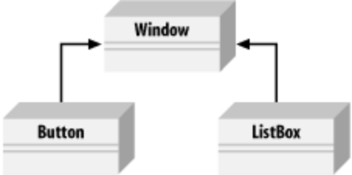
It is not uncommon for two classes to share functionality. When this occurs, you can factor out these commonalities into a shared base class, which is more general than the more specialized classes. This provides you with greater reuse of common code and gives you code that is easier to maintain.
For example, suppose you started out creating a series of objects as illustrated in Figure 11-2. After working with RadioButtons, CheckBoxes, and Command buttons for a while, you realize that they share certain characteristics and behaviors that are more specialized than Window but more general than any of the three. You might factor these common traits and behaviors into a common base class, Button, and rearrange your inheritance hierarchy as shown in Figure 11-3. This is an example of how generalization is used in object-oriented development.
Figure 11-2. Objects deriving from Window
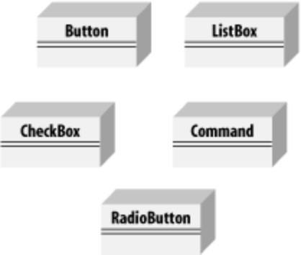
Figure 11-3. Factoring a Button class
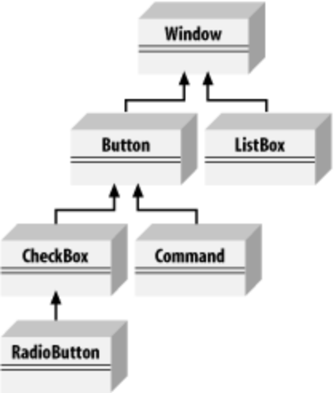
The UML diagram in Figure 11-3 depicts the relationship among the factored classes and shows that both ListBox and Button derive from Window and that Button is specialized into CheckBox and Command. Finally, RadioButton derives from CheckBox. You can thus say that RadioButton is a CheckBox, which in turn is a Button, and that Buttons are Windows.
This is not the only, or even necessarily the best, organization for these objects, but it is a reasonable starting point for understanding how these types (classes) relate to one another.
Actually, although this might reflect how some widget hierarchies are organized, I am very skeptical of any system in which the model does not reflect how I perceive reality, and when I find myself saying that a RadioButton is a CheckBox, I have to think long and hard about whether that makes sense. I suppose a RadioButton is a kind of checkbox. It is a checkbox that supports the idiom of mutually exclusive choices. That said, it is a bit of a stretch and might be a sign of a shaky design.

11.2 Inheritance
In C#, the specialization relationship is implemented using a principle called inheritance. This is not the only way to implement specialization, but it is the most common and most natural way to implement this relationship.
Saying that ListBox inherits from (or derives from) Window indicates that it specializes Window. Window is referred to as the base class, and ListBox is referred to as the derived class. That is, ListBox derives its characteristics and behaviors from Window and then specializes to its own particular needs.
11.2.1 Implementing Inheritance
In C#, you create a derived class by adding a colon after the name of the derived class, followed by the name of the base class:
public class ListBox : Window
This code declares a new class, ListBox, that derives from Window. You can read the colon as "derives from."
The derived class inherits all the members of the base class (both member variables and methods). These members can be treated just as if they were created in the derived class.
The derived class is free to implement its own version of a base class method. This is called hiding the base class method and is accomplished by marking the method with the keyword new.
This is a different use of the keyword new than you've seen earlier in this book. In Chapter 8, new was used to create an object on the heap; here new is used to replace the base class method. Programmers say the keyword new is overloaded, which means that the word has more than one meaning or use.

The new keyword indicates that the derived class has intentionally hidden and replaced the base class method, as shown in the Example 11-1. (The new keyword is also discussed in Section 11.3.2, later in this chapter.)
Example 11-1. Deriving a new class
using System;

public class Window
{
// constructor takes two integers to
// fix location on the console
public Window(int top, int left)
{
this.top = top;
this.left = left;
}

// simulates drawing the window
public void DrawWindow()
{
Console.WriteLine("Drawing Window at {0}, {1}",
top, left);
}

// these members are private and thus invisible
// to derived class methods; we'll examine this
// later in the chapter
private int top;
private int left;
}

// ListBox derives from Window
public class ListBox : Window
{
// constructor adds a parameter
public ListBox(
int top,
int left,
string theContents):
base(top, left) // call base constructor
{
mListBoxContents = theContents;
}

// a new version (note keyword) because in the
// derived method we change the behavior
public new void DrawWindow()
{
base.DrawWindow(); // invoke the base method
Console.WriteLine ("Writing string to the listbox: {0}",
mListBoxContents);
}
private string mListBoxContents; // new member variable
}

public class Tester
{
public static void Main()
{
// create a base instance
Window w = new Window(5,10);
w.DrawWindow();

// create a derived instance
ListBox lb = new ListBox(20,30,"Hello world");
lb.DrawWindow();
}
}
Output:
Drawing Window at 5, 10
Drawing Window at 20, 30
Writing string to the listbox: Hello world
Example 11-1 starts with the declaration of the base class Window. This class implements a constructor and a simple DrawWindow() method. There are two private member variables, top and left. The program is analyzed in detail in the following sections.
11.2.2 Calling Base Class Constructors
In Example 11-1, the new class ListBox derives from Window and has its own constructor, which takes three parameters. The ListBox constructor invokes the constructor of its parent by placing a colon (:) after the parameter list and then invoking the base class constructor with the keyword base:
public ListBox(
int theTop,
int theLeft,
string theContents):
base(theTop, theLeft) // call base constructor
Because classes cannot inherit constructors, a derived class must implement its own constructor and can only make use of the constructor of its base class by calling it explicitly.
If the base class has an accessible default constructor, the derived constructor is not required to invoke the base constructor explicitly; instead, the default constructor is called implicitly. However, if the base class does not have a default constructor, every derived constructor must explicitly invoke one of the base class constructors using the base keyword. The keyword base identifies the base class for the current object.
As discussed in Chapter 8, if you do not declare a constructor of any kind, the compiler creates a default constructor for you. Whether you write it yourself or you use the one provided by default by the compiler, a default constructor is one that takes no parameters. Note, however, that once you do create a constructor of any kind (with or without parameters) the compiler does not create a default constructor for you.

11.2.3 Overriding Base Methods
Notice in Example 11-1 that ListBox implements a new version of DrawWindow():
public new void DrawWindow()
The keyword new indicates that the programmer is intentionally creating a new version of this method in the derived class.
In Example 11-1, the DrawWindow() method of ListBox hides and replaces the base class method. When you call DrawWindow() on an object of type ListBox, it is ListBox.DrawWindow() that is invoked, not Window.DrawWindow(). Note, however, that ListBox.DrawWindow() can invoke the DrawWindow() method of its base class with the code:
base.DrawWindow(); // invoke the base method
11.2.4 Controlling Access
You can restrict the visibility of a class and its members through the use of access modifiers, such as public, private, and protected. (See Chapter 8 for a discussion of access modifiers.)
As you've seen, public allows a member to be accessed by the member methods of other classes, while private indicates that the member is visible only to member methods of its own class. The protected keyword extends visibility to methods of derived classes.
Classes as well as their members can be designated with any of these accessibility levels. If a class member has a different access designation than the class, the more restricted access applies. Thus, if you define a class, myClass, as follows:
public class myClass
{
// ...
protected int myValue;
}
the accessibility for myValue is protected even though the class itself is public. A public class is one that is visible to any other class that wishes to interact with it.

